Ethos-style collimation demonstrator
A palm-sized teaching model with no motors and no electronics beyond one LED (light-emitting diode). A green light source turns by hand around a closed bore. The bore wall carries seven fixed openings, one per gantry stop. Each opening is the exact projection of the same heart drawn on the couch, so at every stop the light lands on the same heart, although every opening has a different shape. That is the MLC (multileaf collimator) principle in one object: the aperture changes with the angle so that the target does not.
This is a teaching model, not a medical device. It is meant for patients, students and visitors, so keep it simple to operate and safe to touch.

1. How it works
The light source is a 5 mm green LED sitting behind a 1 mm pinhole, 100 mm from the rotation axis. It behaves as a point source, so every opening casts a sharp divergent shadow. The couch surface contains the rotation axis, which means the heart engraved on it sits exactly at the isocentre.
Each opening is cut as the intersection of the bore wall with the divergent beam that reaches the heart. Two consequences follow: the edges are bevelled towards the source, like focused MLC leaves, and the shape of each opening differs from every other, because the heart is seen from a different angle each time.
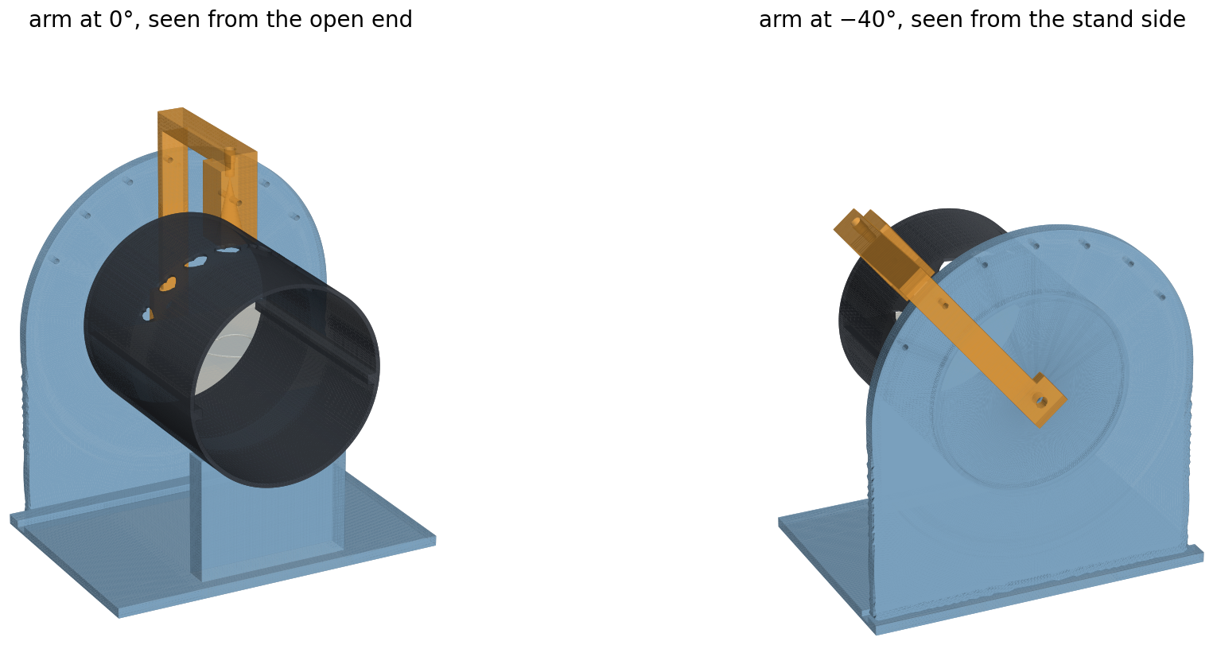
Figure 1 — Two views of the assembled demonstrator: the bore with its openings, the couch inside, and the arm carrying the light head.
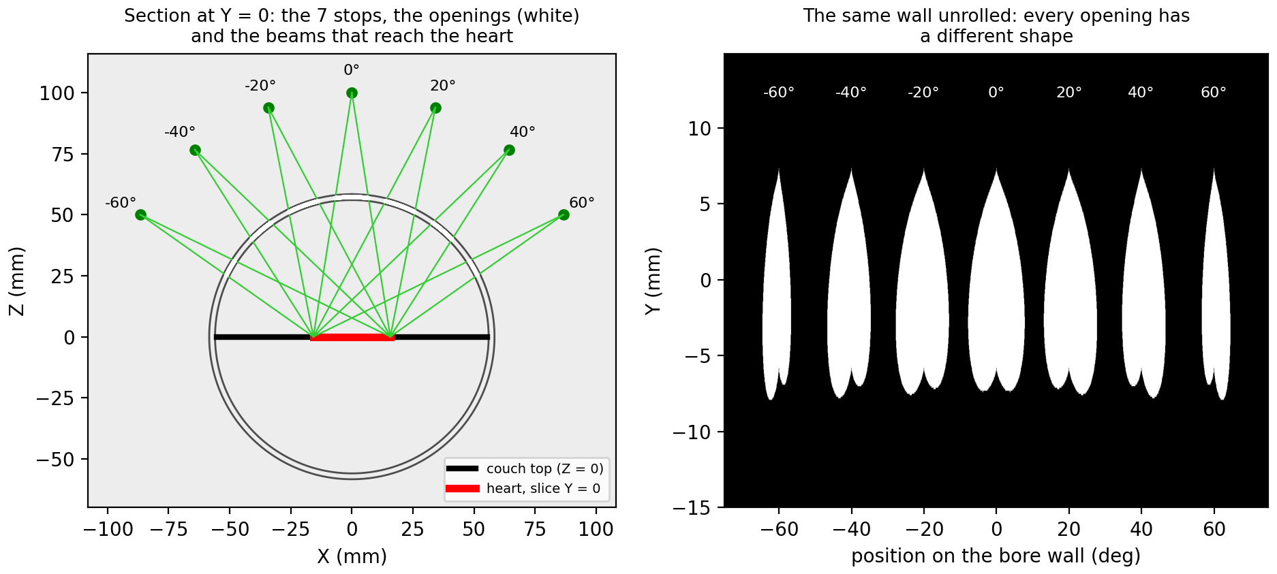
Figure 2 — Left: the beams at the seven stops. Right: the bore wall unrolled, showing that no two openings are alike.

Key dimensions
Quantity | Value | Comment
Pinhole (source) radius | 100 mm from the axis | equivalent of the SAD (source-to-axis distance)
Bore wall | inner radius 56.0 mm, outer 58.4 mm | 2.4 mm thick, prints solid with 4 perimeters
Bore length | 130 mm | open at the viewing end
Gantry stops | −60°, −40°, −20°, 0°, +20°, +40°, +60° | set by a pin through the arm
Target | heart about 34 × 34 mm | engraved groove on the couch
Opening size | about 12–15 mm | roughly 0.44 × the heart, as it sits closer to the source
Edge blur (penumbra) | about 1.3 mm | with a 1 mm pinhole; smaller is sharper but dimmer
Overall size | 200 × 140 × 215 mm | largest printed part 192 × 212 mm

Why the light does not leak through the neighbouring openings
From any stop, the source also sees the two neighbouring openings, which would throw stray patches onto the couch. A 12.5° cone inside the head, playing the role of the primary collimator, solves this: each stop's own opening lies within 11.5° of the beam axis, while the nearest other opening is at least 16.0° away. The generator script checks both numbers if you change the design.
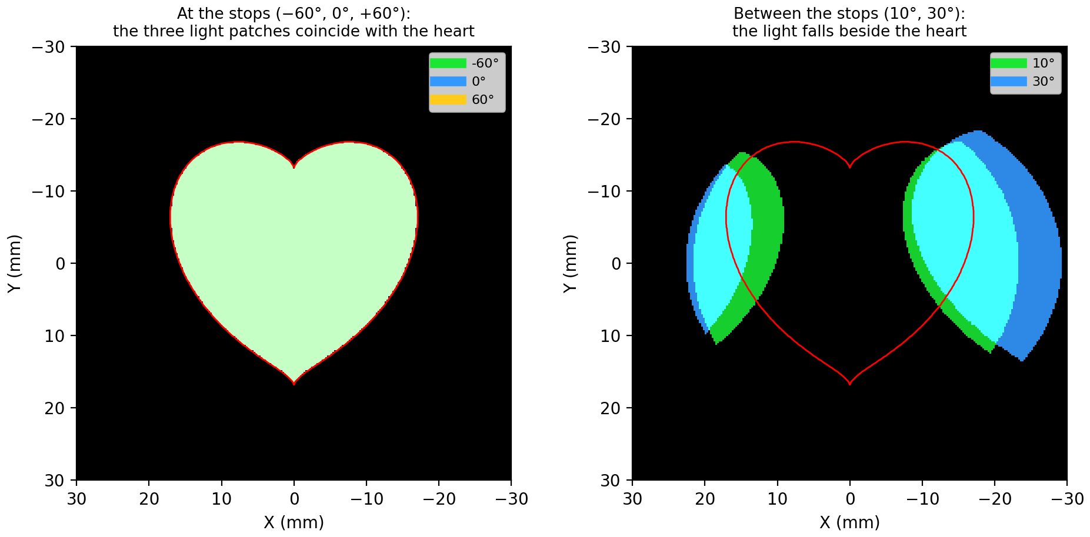
Figure 3 — On the left, the patches at three different stops land on the same heart. On the right, between the stops the light misses it.

2. Printed parts
File | Material | Printing
1_bore_collimator.stl | black, opaque | Standing on one end, 4 perimeters, no supports. The opening tops bridge up to about 15 mm; clean any sag with a knife. Two internal rails carry the couch.
2_couch_top.stl | white | Flat. The heart outline is a 1 mm wide, 0.6 mm deep groove; darken it with a fine marker if you like.
3_stand_end_plate.stl | any colour | Flat, groove side up.
4_base_with_cradle.stl | any colour | As is. The cradle supports the front end of the bore.
5_gantry_arm_with_head.stl | black, opaque | Lying on its flat side, where hub, arm, beam and head are flush. No supports.

Black matters for the bore and the head: light passing through a translucent wall would wash out the demonstration. A 220 × 220 mm bed is enough.

3. Other parts
- M6 × 25 bolt, two washers and a lock nut for the gantry axle.
- M3 × 20 screw or a 3 mm pin for the indexing stops.
- One high-brightness green LED, 5 mm, with a viewing angle of 30° or less.
- A 100 Ω resistor and a 5 V USB (universal serial bus) supply, giving about 19 mA, plus thin wire and an optional switch.
- A 1.0 mm drill bit in a pin vice, to open the pinhole (it is printed at 0.9 mm).
- Glue.

4. Assembly
- Push the end plate into the slot of the base, with the circular groove facing the cradle.
- Pass the M6 bolt through the plate from the groove side, so the head ends up inside the bore. Add a washer, then the arm hub on the outside of the plate, then a washer and the lock nut. Tighten until the arm turns with light friction and stays where you leave it.
- Seat the bore in the groove of the plate; its front end rests in the cradle.
- Slide the couch top onto the two internal rails from the open end, heart tip towards the open end.
- Ream the pinhole to 1.0 mm. Push the LED into the pocket at the top of the arm, dome first, until it touches the pinhole wall. Wire it in series with the resistor and route the wires along the arm.
- Turn the arm to a stop and drop the pin through the arm into the matching hole of the plate.

5. Running the demonstration
Dim the room and let the visitor look into the bore from the open end. At each stop the heart lights up completely, and nothing else does. Pull the pin, turn the arm, and the patch slides off the heart until the next stop catches it.
That sequence carries the message in about thirty seconds: the machine turns around the patient, the opening is reshaped for each direction, and only the target is hit every time. Two follow-up points are worth making if the visitor is interested:
- Why the light is off while the gantry moves. Between stops the beam falls on healthy tissue, which is exactly why real treatment is delivered either at fixed angles or with the aperture continuously reshaped while the gantry turns.
- What real treatment adds. Here the openings are fixed metal, or rather fixed plastic. On a real machine, tungsten leaves move into a new shape for every angle, which is what MLC means. Depth also matters: light stops at the surface, radiation goes through.

An honest technical note
With one fixed opening per angle, this model shows conformal multi-field therapy rather than IMRT (intensity-modulated radiotherapy), which requires several openings per angle to vary the intensity across the target. Adding two or three smaller openings per stop would demonstrate that too, provided the primary-collimator cone still separates the groups.

6. Changing the design
This publication edition does not include parametric source code or fabrication-ready STL files. The illustrated geometry is a design specification only. A future source release must bundle the executable generator, pinned dependency versions, all STL outputs, mesh-validity checks, parameter documentation and at least one verified test print.
Until that package exists and has been tested, the model should not be presented as ready to print. Dimensions and clearances must be verified independently before fabrication.

Website publication package
A deliberately simple ring-gantry model shows that each beam angle needs a different aperture even though every field aims at the same target. The absence of motors makes the geometry easy to inspect and the result reliable for public demonstrations.

What visitors will learn
• The target stays fixed while the source direction changes.
• Each viewing angle requires a different projected aperture.
• Primary collimation prevents neighbouring openings from contributing stray light.

Development status and evidence
Stage | Work product | Publish when
Geometry prototype | One source position, aperture and engraved target | Target is fully illuminated with a sharp edge
Seven-angle assembly | Indexed arm, bore and all apertures | Correct patch at all stops and no neighbour patch on target
Rebuild test | Disassemble and reassemble | Alignment is recovered using documented features
Public demonstration | Thirty-second script and labelled video | Viewers can explain the core principle

Evidence to publish with the project
• A versioned bill of materials with purchase date, supplier, measured dimensions and substitutions.
• Downloadable CAD, code and configuration files with a licence and changelog.
• A complete calibration dataset, acceptance results and at least one failed or superseded design, with the reason for changing it.
• A short demonstration video, a labelled system diagram and a plain-language explanation separate from the technical build guide.
• A prominent statement that this is an educational model and not a medical device, clinical QA system or dosimetry instrument.

