Penumbra Box Build Guide
  - A low cost visible light experiment for geometric field edges
Radiotherapy Engineering Lab | Publication edition 1.2 | September 2026
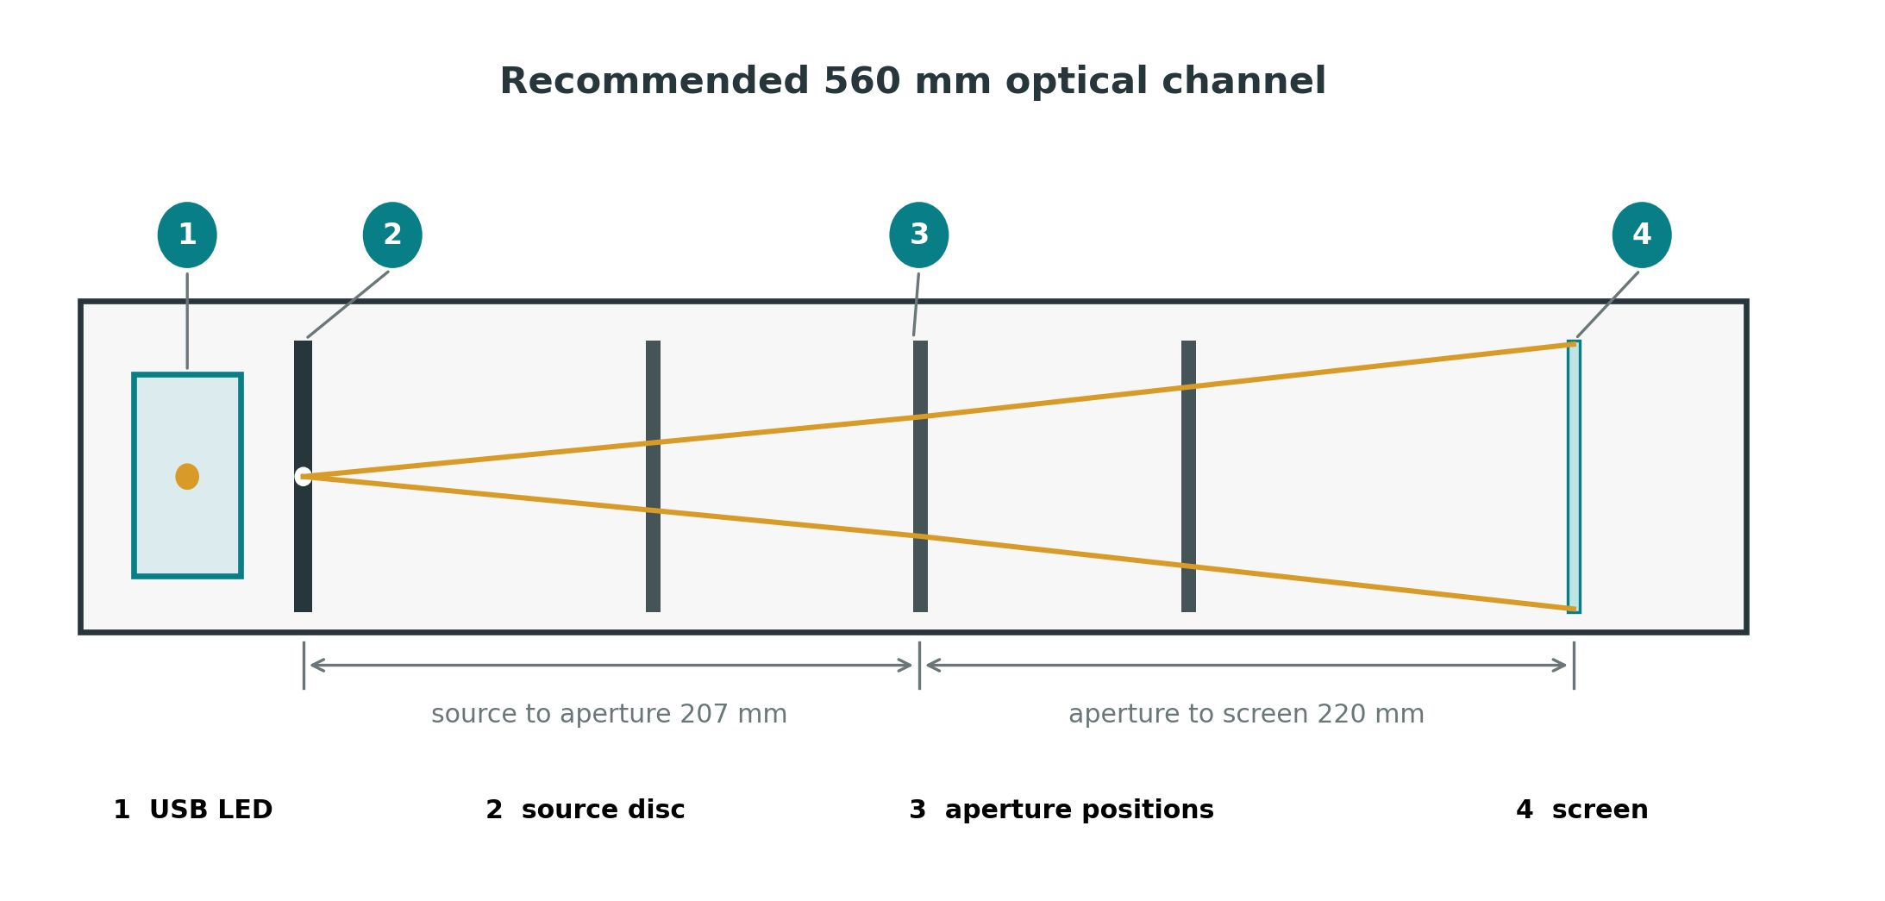
Figure 1 The complete optical channel uses a source disc, a movable aperture and a translucent screen.
What this guide delivers A reproducible tabletop experiment that shows how effective source size and geometry broaden a projected field edge. The complete build can be made from card, tracing paper and a USB LED, then measured with an ordinary smartphone.
Scientific boundary The apparatus demonstrates geometric penumbra. Image brightness is not radiation dose, and the model does not reproduce collimator transmission, patient scatter, secondary electron transport or detector volume effects.

1 Learning objectives
After completing the experiment, a learner should be able to explain why a finite source produces a gradual field edge, predict how aperture position changes geometric penumbra, distinguish magnification from edge broadening, and measure an optical 80 to 20 percent transition without confusing it with clinical dosimetry.
- Relate effective source size to edge sharpness.
- Relate aperture to screen distance to geometric penumbra.
- Recognise displacement and asymmetry caused by misalignment.
- Acquire a repeatable image and calculate an 80 to 20 percent edge width.
- State which components of clinical megavoltage penumbra are absent from the model.

2 Principle
A point source would cast a perfectly sharp geometrical shadow in an ideal system. A real source has finite width. Each point across that source projects a slightly displaced image of the aperture. Where all projected images overlap, the field is fully illuminated. Near the edge, only some source points contribute, creating a gradual transition.
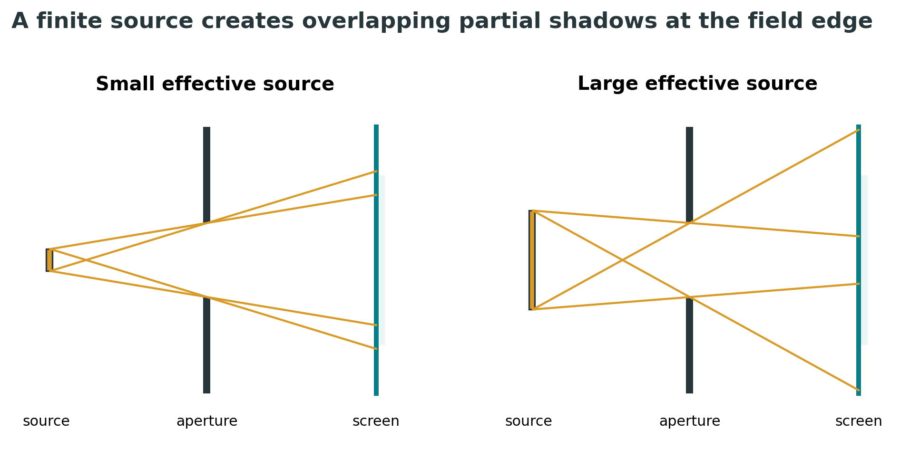
Figure 2 Larger effective sources create a wider region of partial illumination.
For the simple paraxial geometry used here, the approximate geometric penumbra width is
p approximately equals s multiplied by b divided by a
where p is the penumbra width at the screen, s is the effective source width, a is the source to aperture distance, and b is the aperture to screen distance. This relationship is an approximation: thick or irregular apertures, an extended LED emitting nonuniformly, screen diffusion and camera processing can alter the measured profile.

3 Bill of materials
Part | Recommended specification | Low cost substitute
Optical channel | Black foam board or corrugated card, 560 x 120 x 120 mm | Long shoebox or two joined cereal boxes
Light source | 5 V prewired white or green 5 mm LED | USB reading light with diffuser removed
Source discs | 0.5, 1, 2, 4 and 8 mm openings in opaque card | Foil sandwiched between two card layers
Field apertures | 12 mm square and 14 mm circle in matte black card | Two layers of dark card
Observation screen | Tracing paper or drafting film | Baking parchment tested for uniformity
Scale | Printed millimetre strip | Transparent school ruler beside the screen
Camera | Smartphone with exposure lock | Visual comparison only
Supports | Card slots or binder clips | Modelling clay outside the optical path
Stray light control | Black lid or dark cloth | Dim room
Expected cost EUR 5 to 15 when a smartphone and USB supply are already available. No laser is required.

4 Recommended dimensions
Dimension | Nominal value | Acceptable range
Channel length | 560 mm | 450 to 700 mm
Internal width and height | 120 x 120 mm | At least 90 x 90 mm
LED to source disc | 15 mm | 10 to 25 mm
Source to aperture position 1 | 115 mm | Record actual value
Source to aperture position 2 | 205 mm | Record actual value
Source to aperture position 3 | 295 mm | Record actual value
Source to screen | 427 mm | 350 to 600 mm
Square aperture | 12 x 12 mm | 8 to 20 mm
Screen active area | 80 x 80 mm | At least 60 x 60 mm

5 Construction
- Cut a 560 x 120 mm base and two 560 x 120 mm side walls. Join them into a U shaped channel. Add a removable top after alignment.
- At one end, make a light compartment that holds the LED on the optical axis. Place the interchangeable source disc 10 to 25 mm in front of the LED.
- Cut three pairs of opposing vertical slots for the field aperture. Measure the source to aperture distance from the source disc plane, not from the LED dome.
- Build a screen frame at the far end. Stretch tracing paper flat without wrinkles. Attach a millimetre scale in the same plane as the screen.
- Add a central reference line along the base and screen. The source opening, aperture centre and screen centre must initially lie on this axis.
- Paint or line internal surfaces matte black. Close the lid and inspect for stray light before taking measurements.

Source discs
The source disc controls the effective emitting width more reliably than the LED lens. Make at least five opaque discs with nominal openings of 0.5, 1, 2, 4 and 8 mm. Photograph each opening beside a ruler or inspect it with a magnifier; record the measured diameter rather than trusting the drill or punch label.

Field aperture
Begin with a 12 mm square aperture because its straight edge simplifies profile measurement. Add a circular aperture only after the basic experiment works. Keep the card perpendicular to the axis and use two layers if light leaks through the material.
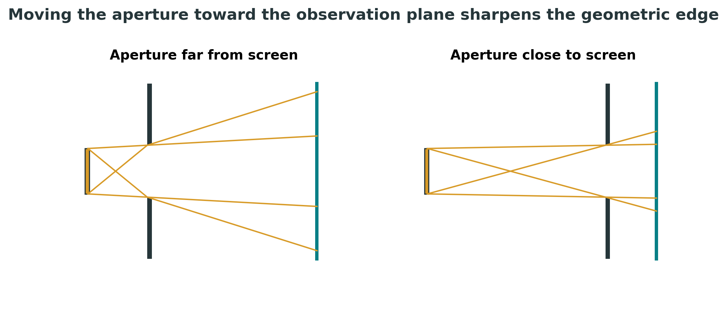
Figure 3 Reducing aperture to screen distance narrows the geometrical transition.

6 Alignment and commissioning
- Install the 1 mm source disc and the middle aperture position.
- Place a paper crosshair on the screen. Adjust the LED holder until the projected field is centred.
- Rotate the square aperture by 180 degrees. If the field centre moves, the aperture opening or holder is asymmetric.
- Reverse each source disc. A change in projection suggests a burr or bevel that clips the source.
- Take three photographs without moving the apparatus. The measured edge width should agree within the chosen repeatability tolerance.
- Record the actual distances a and b, the source opening, aperture size, room lighting, camera model, zoom, exposure and focus settings.

Suggested acceptance checks
Check | Practical criterion | Action if it fails
Centred field | Centre within 2 mm of crosshair | Realign source and aperture
Symmetry | Opposite edge widths within 15 percent | Inspect tilt, burrs and screen flatness
Repeatability | Three widths within 0.5 mm or 10 percent | Lock camera and apparatus
Stray light | Background under 5 percent of field centre | Seal box and blacken surfaces
Camera saturation | No clipped central pixels | Reduce exposure or LED current
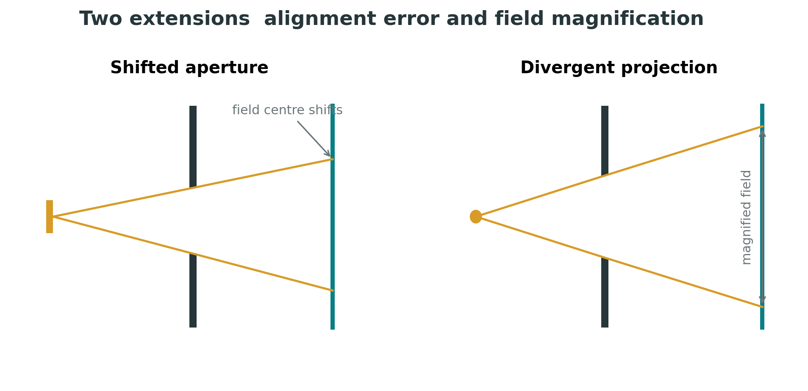
Figure 4 Misalignment shifts the field; divergence magnifies the aperture projection.

7 Experiment one source size
Question How does effective source diameter change the width of the projected edge when all distances remain fixed
- Choose the middle aperture position and record a and b.
- Install the 0.5 mm source disc. Lock the smartphone on a stand perpendicular to the screen.
- Lock focus, exposure, white balance and zoom. Avoid automatic HDR or portrait processing.
- Photograph the square field with the ruler visible.
- Repeat for 1, 2, 4 and 8 mm discs without moving the aperture, screen or camera.
- Compare the images visually, then complete the quantitative analysis in section 10.
Prediction Penumbra width should rise approximately linearly with effective source width. Very small openings may become too dim or may reveal diffraction only at scales much smaller than the intended classroom measurement.

8 Experiment two aperture position
Question How does aperture to screen distance change geometric penumbra
- Install the 2 mm source disc.
- Place the aperture at the slot nearest the source and record a and b.
- Acquire a photograph using the locked camera settings.
- Repeat at the middle and screen side slots.
- Compare both field size and edge width. Do not mistake magnification for penumbra.
Prediction Moving the aperture toward the screen reduces b and therefore narrows the geometric penumbra. The projected field size also changes because the light diverges.

9 Experiment three deliberate misalignment
Shift the aperture laterally by 2 mm, then tilt it by approximately 3 degrees. Record field centre, left and right edge widths, and the shape of the projected square. This makes mechanical QA tangible: a small positioning error can displace or distort the field even when the source itself has not changed.

10 Smartphone measurement of the field edge
The measurement uses image brightness as an optical signal. It is not a dose profile. Consistency matters more than camera sophistication.
- Use a tripod or rigid support. Frame the screen squarely and include the millimetre scale in the same plane.
- Lock exposure and focus. Ensure the centre of the field is below saturation.
- Select a narrow horizontal strip crossing one straight field edge. Average several adjacent pixel rows to reduce noise.
- Subtract the background measured outside the field.
- Normalise the plateau inside the field to 100 percent.
- Find the positions where the profile crosses 80 percent and 20 percent. Convert their pixel separation to millimetres using the ruler.
- Report the 80 to 20 percent width, the acquisition settings and the uncertainty of locating each crossing.
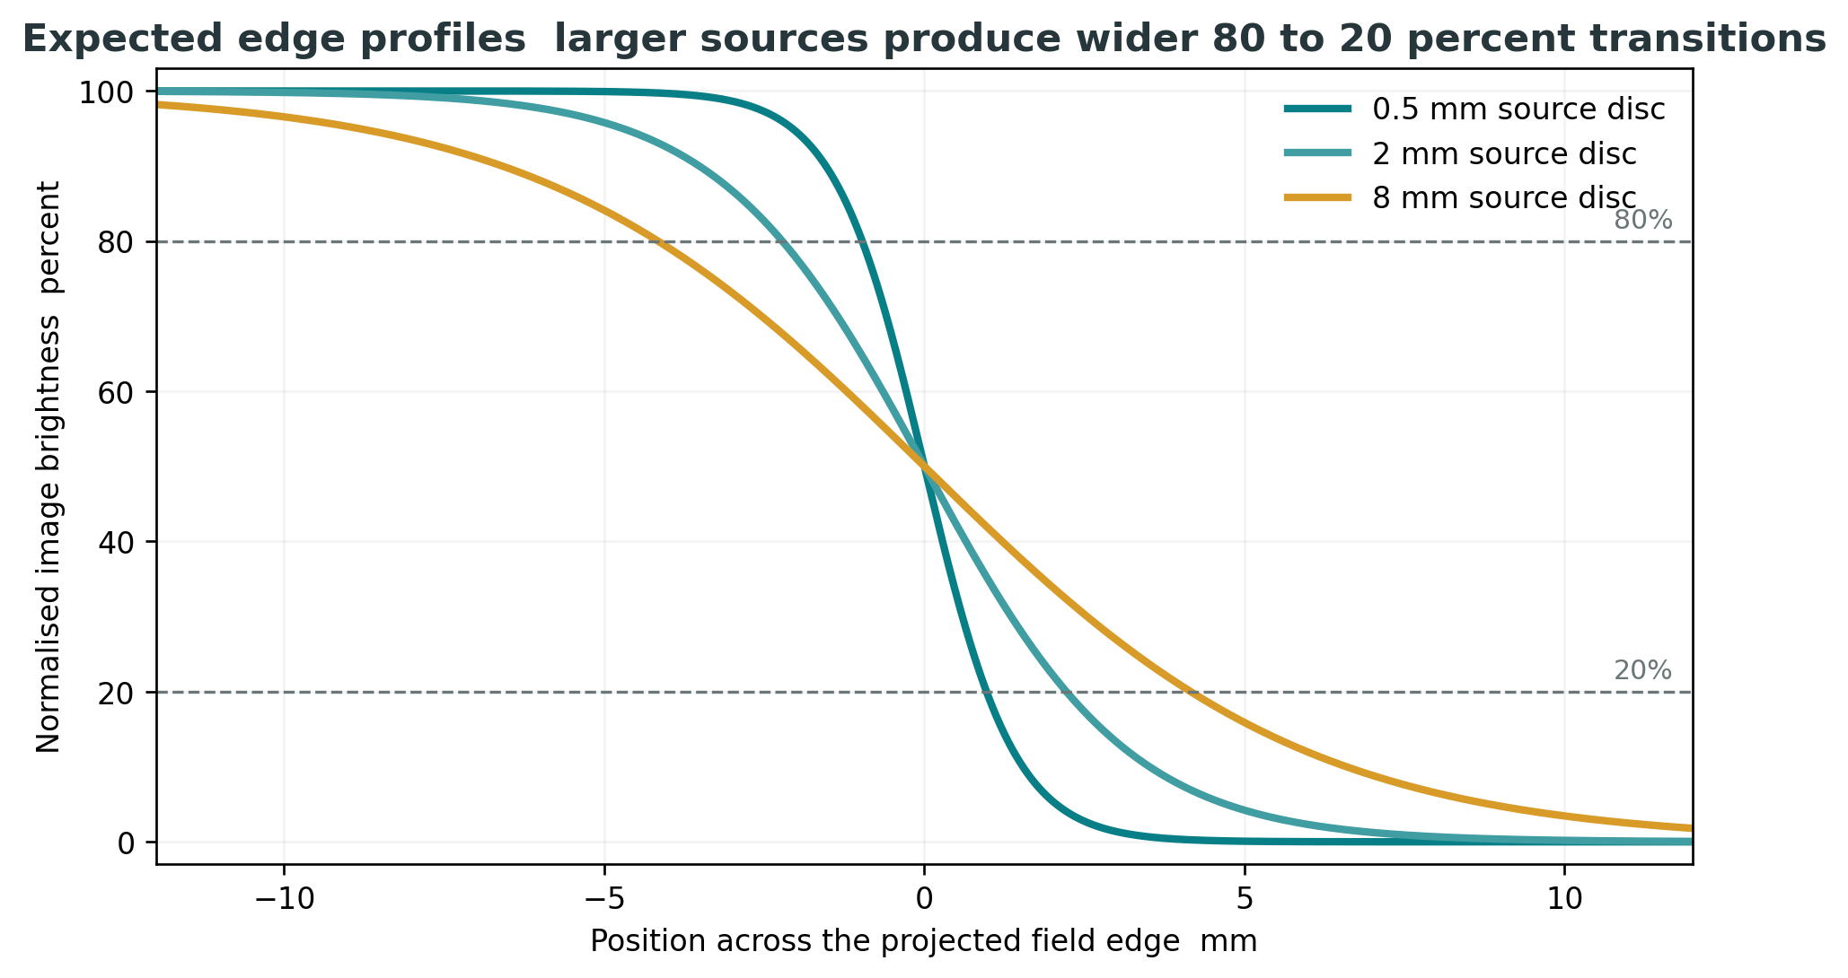
Figure 5 Illustrative profiles show the expected trend, not calibration data from a completed apparatus.

A manual alternative
If no image analysis software is available, print each photograph at the same scale. Mark the visually uniform plateau and background, then compare edge widths against the millimetre ruler. This is qualitative and observer dependent, but it still reveals the direction of change.

11 Data sheet
Run | Source mm | a mm | b mm | Field width mm | 80 to 20 width mm | Notes
1
2
3
4
5
6
7
8

Observation notes
________________________________________________________________________________
________________________________________________________________________________
________________________________________________________________________________
________________________________________________________________________________
________________________________________________________________________________
________________________________________________________________________________

12 Interpretation

What the model reproduces
- Geometric field divergence and magnification.
- Partial shadow caused by a finite effective source.
- Dependence of geometric penumbra on source size and aperture geometry.
- Field displacement and asymmetry caused by mechanical misalignment.
- The need for repeatable acquisition, calibration, tolerances and documented QA.

What the model does not reproduce
- Megavoltage photon attenuation and energy deposition in tissue.
- Transmission through treatment jaws or multileaf collimator leaves.
- Scatter from the treatment head, patient or phantom.
- Secondary electron transport and depth dependent lateral dose spread.
- Detector volume averaging or a clinically commissioned dose profile.
The correct conclusion is therefore limited but valuable: visible light can model the geometric contribution to a treatment field edge and make the controlling variables directly observable.

13 Troubleshooting
Observation | Likely cause | Correction
No recognisable field | Source is too broad or aperture is not opaque | Install a source disc and double the aperture card
Field is dim | Opening too small, LED too far back, screen too dense | Use 1 or 2 mm source and thinner tracing paper
Bright halo everywhere | Internal reflections or light leaks | Blacken interior and close the lid
One edge is broader | Aperture tilt, source offset or screen tilt | Realign sequentially from source to screen
Profile changes between images | Automatic exposure, focus or HDR | Lock camera settings and use a fixed support
Edge looks artificially sharpened | Phone processing | Disable enhancement or use raw capture if available

14 Printable cutting templates
The following page is intended for direct printing. Print at 100 percent with page scaling disabled. Measure the 50 mm check line before using any template. Printer scaling errors directly alter the source and aperture sizes.

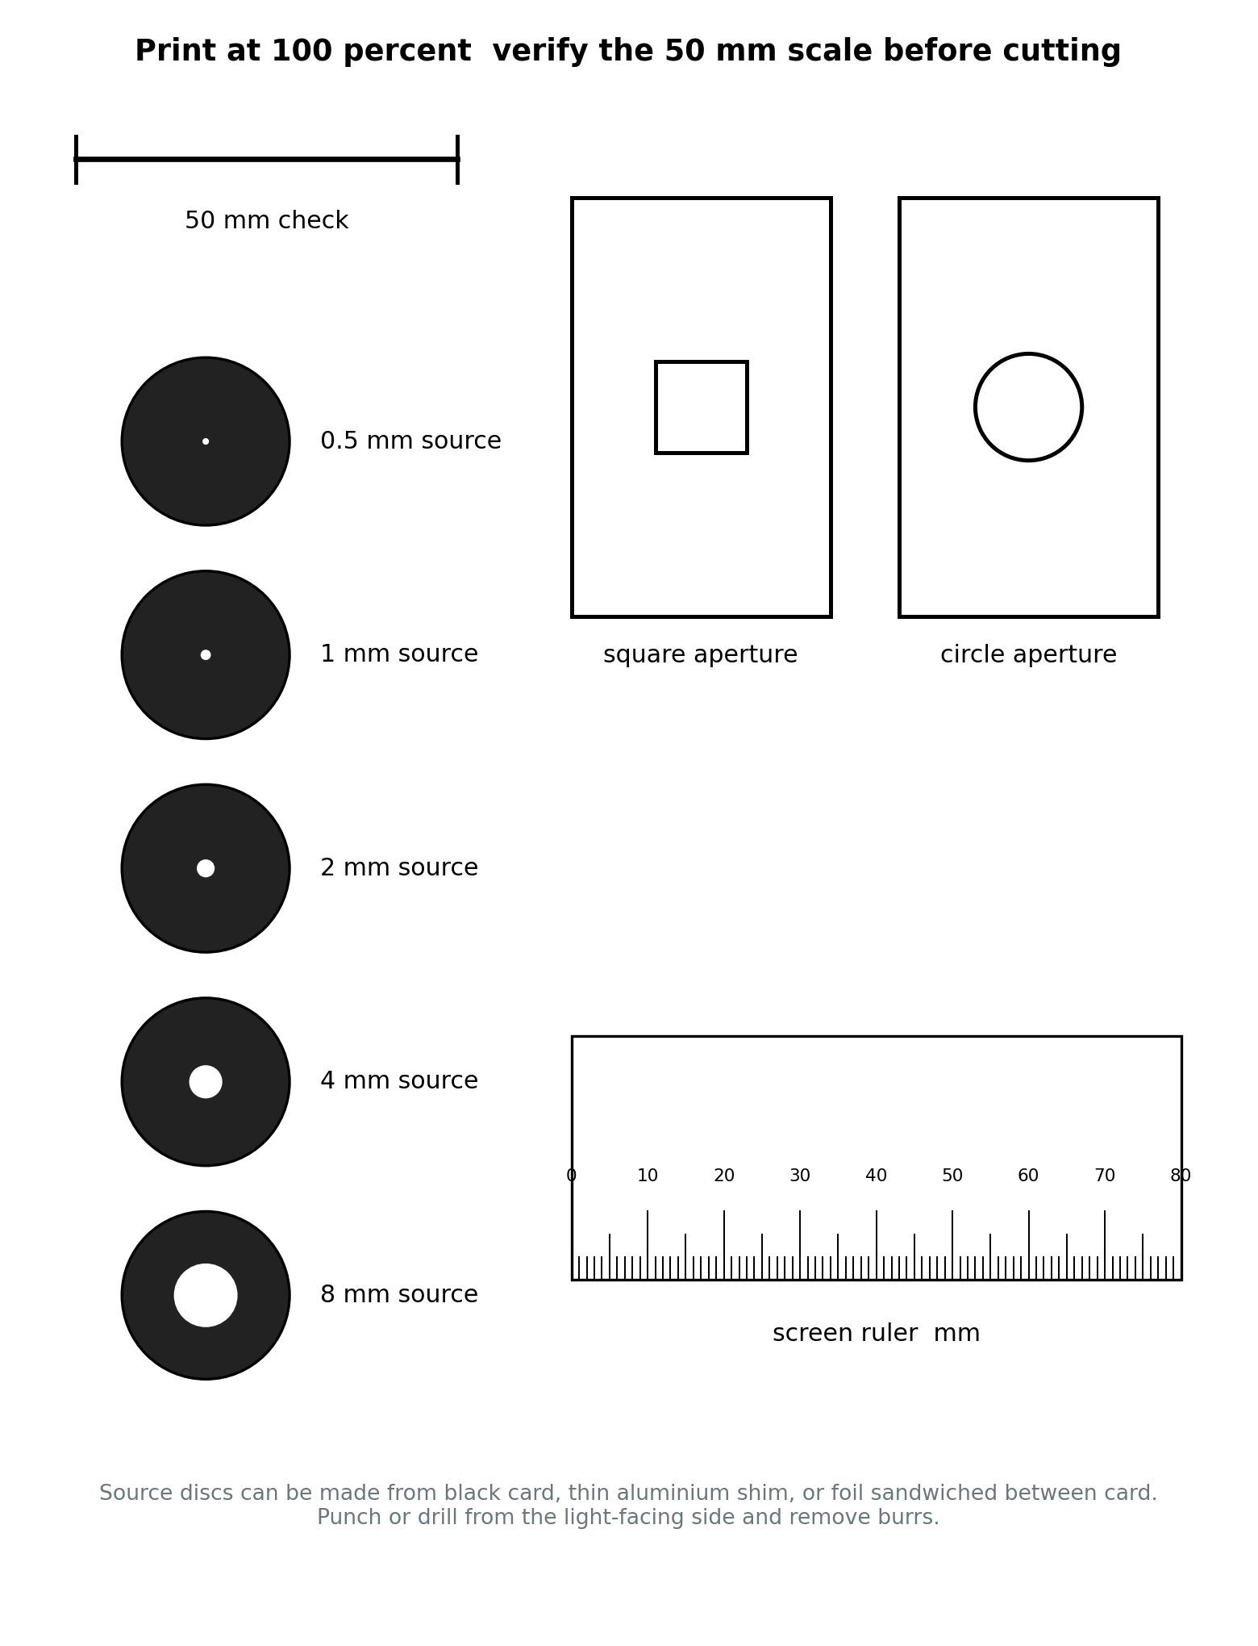
Figure 6 Source discs, aperture cards and a screen ruler. Verify scale before cutting.

15 Publication and evidence package
A website release should include this guide, a one page build sheet, the printable template, three representative photographs, a short demonstration video, a blank data sheet and at least one completed dataset. Publish the measured dimensions of the actual build rather than only the nominal drawing.

Suggested project card
The Penumbra Box
A tabletop optical experiment showing why treatment field edges are never perfectly sharp.
What it demonstrates Effective source size, geometric penumbra, aperture position, magnification and alignment.

Versioning
- Assign a version to the guide, template and dataset.
- Record every change to source discs, distances, aperture material or screen.
- Keep failed measurements when they explain a design correction.
- State clearly whether results are predicted, simulated or experimentally measured.
The companion vector drawing package contains each diagram as an editable SVG file. Text, lines, colours and dimensions can be changed in a vector editor, and current desktop versions of Microsoft Word can insert SVG artwork without raster degradation.

Educational scope
This apparatus is an educational visible light demonstrator. It is not a medical device, treatment planning system, dosimeter or clinical QA instrument. It must not be used to infer patient dose or validate a radiotherapy treatment unit.

Licence placeholder
Before publication, insert the final licence selected for the written guide, diagrams and hardware design files. Keep the radioterapie.eu name and logo outside any open licence unless their reuse is explicitly intended.

References and further reading
- E B Podgorsak editor. Radiation Oncology Physics A Handbook for Teachers and Students. International Atomic Energy Agency. Vienna 2005.
- F M Khan and J P Gibbons. The Physics of Radiation Therapy. Standard chapters on treatment machine geometry, field size and penumbra.
- AAPM Task Group 142. Quality assurance of medical accelerators. Medical Physics 2009;36:4197 to 4212.
- IEC 60976. Medical electrical equipment Medical electron accelerators Functional performance characteristics.

