Robotic arm demonstrator with camera feedback
A benchtop model of robotic radiosurgery: a small 6-axis arm aims a laser pointer, standing in for the treatment beam, at a phantom from many non-coplanar directions. The arm's own precision is far from clinical, so a pair of cameras measures where the beam actually points and the arm is corrected before each "beam on". This document covers the accuracy model, the bench, the calibration, the correction loop, and how to measure whether it worked.
Teaching and development model, not a medical device. Nothing here transfers to clinical quality assurance. The figures for achievable accuracy are engineering estimates and must be measured on your own build.

1. What "accuracy" means here
Two numbers get confused constantly, and the whole project depends on separating them.
- Repeatability is how consistently the arm returns to a position it has already visited. This is the number vendors quote, for example 0.2 mm.
- Absolute accuracy is how close the tool gets to a Cartesian coordinate you command. On a low-cost arm it is often three to ten times worse than the repeatability, because the controller uses nominal link lengths and joint zeros rather than the real ones.
Calibration mostly improves absolute accuracy. Only external feedback can beat the repeatability limit, and even then the floor is set by backlash, compliance and the smallest motion the joints can actually make.
For this project a third number matters more than either: the pointing error at the isocentre, that is, the distance between where the laser lands and the centre of the phantom, measured over the whole set of beam directions. That is the analogue of the Winston-Lutz test used clinically.

Candidate arms
Arm | Axes | Stated repeatability | Indicative price | Notes
WLKATA Mirobot | 6 (+1) | 0.2 mm | about €1,540 (Professional Kit) | Cheapest 6-axis at this class. Stepper driven; confirm with the vendor whether the joints have any feedback.
Elephant Robotics myCobot 280 | 6 | ±0.5 mm | from about $499 | Cheaper and ROS-friendly, but the coarsest of the three.
Dobot MG400 | 4 | 0.05 mm | about $3,000 | Much more precise, but the tool always points down, so non-coplanar geometry has to come from a rotating and tilting phantom stage.

The camera loop described here suits any of them. The better the mechanics, the fewer iterations it needs.

2. Strategy in three layers
Each layer is useful on its own, and they stack. Do them in order, because the later ones are far easier when the earlier ones are in place.
- Mechanics and operating practice. No calibration survives a wobbly bench. Bolt the arm, the phantom stand and the cameras to one rigid base, such as a granite tile or a thick aluminium plate. Home the arm at the start of every session and let it warm up for fifteen to thirty minutes. Keep the payload far below the rated maximum, avoid fully extended poses, run slowly, and always approach a target from the same direction so gear backlash is taken up the same way.
- Static calibration. Measure the arm rather than trusting its nominal model, then correct the model. This brings absolute accuracy close to the repeatability limit.
- Closed-loop correction. Measure the actual pose with cameras, compute the error, command a correction, and repeat until the error is below tolerance. This is what pushes the result below the repeatability limit, and it is conceptually what image guidance does clinically.
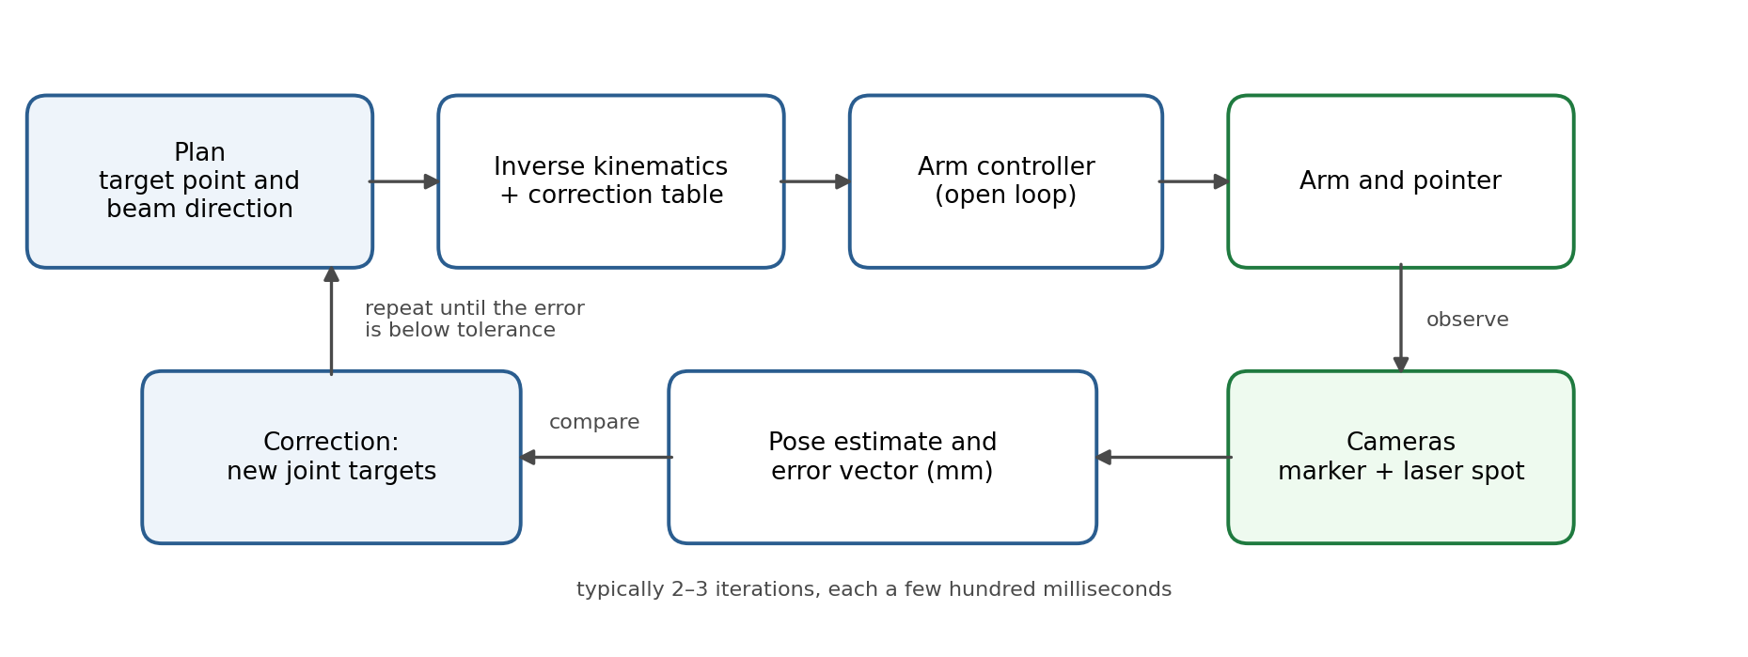
Figure 1 — The correction loop. The arm stays open loop internally; the cameras close the loop around it in Cartesian space.

3. The bench
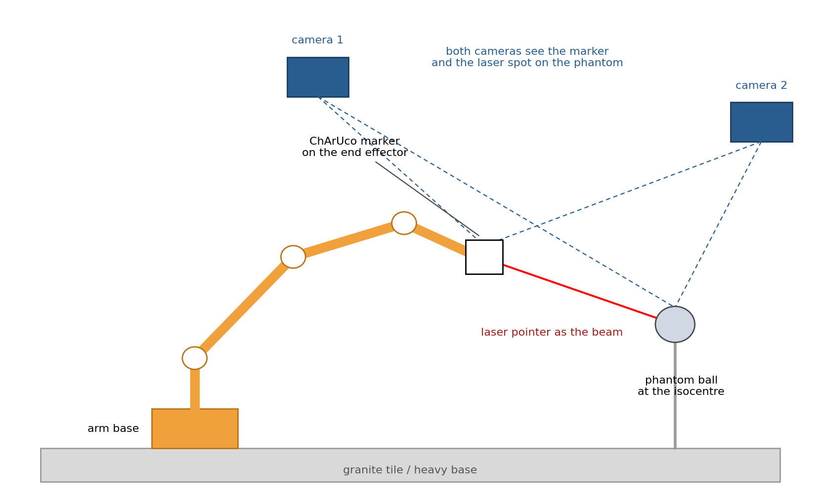
Figure 2 — Bench layout. Both cameras see the marker on the end effector and the laser spot on the phantom.
The phantom is a matte ball, 10 to 20 mm across, on a thin stem, defining the isocentre. The end effector carries a laser pointer and a ChArUco marker board, that is, a chessboard with ArUco codes in the white squares, which gives a more precise pose than a single marker.
Two cameras placed roughly orthogonally give a three-dimensional measurement. They must see both the marker and the laser spot on the phantom, which is what makes the measurement directly meaningful: the spot position is the quantity you care about, and the marker tells you how the tool is oriented.
Item | Suggestion | Approx. cost
Cameras | 2 × global-shutter USB camera, 1920 × 1200, 1/1.8-inch sensor | €120–300
Lenses | Fixed focal length chosen for a field of view of 80–120 mm at the working distance (roughly 25–35 mm at 400 mm) | €60–160
Mounts | Rigid arms or extrusion posts, clamped to the same base as the arm | €40–100
Phantom | Matte ball on a stem, plus a small translucent target screen for spot tests | €20–50
Marker | ChArUco board printed on paper and glued to a flat aluminium plate (printed dimensions must be verified with calipers) | €10
Beam | Class 2 laser module with a stable mount, or a collimated LED | €15–40
Lighting | Diffuse LED panel, and a dark cloth to suppress reflections | €30–60

A pixel at 100 mm field of view over 1920 pixels is about 0.05 mm, and a marker or spot centroid is typically good to a tenth of a pixel, so measurement noise is in the range of 0.005 mm. The measurement is not the limiting factor; the arm is.

4. Calibration procedure
- Camera intrinsics. Photograph a ChArUco board in twenty to thirty poses covering the whole field and all orientations, then run the standard OpenCV calibration. Check the reprojection error; above about 0.3 pixels, repeat with better images.
- Stereo extrinsics. With both cameras seeing the same board, solve for the transform between them. From here, any point seen in both views can be triangulated.
- World frame. Define the world origin at the phantom centre. The simplest way is to image the ball from both cameras and take the centre of its outline; a sphere is convenient because its silhouette centre is pose-independent.
- Hand-eye calibration. Move the arm to twenty or more varied poses, recording the commanded joint angles and the measured marker pose each time, then solve the hand-eye problem (OpenCV's calibrateHandEye). This gives the transform between the end-effector flange and the marker, and between the robot base and the cameras.
- Kinematic fit. Using the same data, fit corrected Denavit-Hartenberg parameters (link lengths, offsets, joint zeros) by least squares, minimising the difference between predicted and measured marker poses. Expect the joint zero offsets to dominate.
- Tool axis. The laser axis is not the marker axis. Aim the beam at a screen at two different distances and triangulate the line; store it as the tool vector.
- Residual error map. Command a grid of poses through the working volume, typically 5 × 5 × 5 points over 50 to 100 mm, record the residual error, and store it as a lookup table with interpolation. Apply it as a feed-forward correction.
Steps 1 to 6 are done once per build; step 7 is worth repeating after any mechanical change.

5. The correction loop
After the feed-forward correction, the residual error is measured and removed iteratively. Because the phantom does not move, the loop can be slow and static: move, settle, measure, correct. There is no need for real-time visual servoing.
def aim(target_xyz, direction, tol=0.05, gain=0.8, max_iter=4):
"""Point the beam at target_xyz from a given direction, to tol (mm)."""
pose = plan_pose(target_xyz, direction) # tool pose from the plan
pose = apply_error_map(pose) # feed-forward correction
for i in range(max_iter):
move_and_settle(pose) # command, then wait for damping
spot = measure_spot() # triangulated laser spot (mm)
err = spot - target_xyz # Cartesian error vector
if norm(err) < tol:
return True, norm(err), i # within tolerance: beam on
pose = translate_tool(pose, -gain * err) # correct in tool coordinates
return False, norm(err), max_iter # do not fire; log and stop
Four practical points:
- Settling time matters. Command the move, wait for the structure to stop vibrating (typically 0.3 to 1 second on a small arm), and only then measure.
- A gain below one avoids oscillation. With 0.8, two or three iterations are usually enough.
- Always approach from the same side. If the correction reverses direction, backlash is taken up differently and the loop converges more slowly. Overshooting deliberately and coming back from a fixed side is a reliable trick.
- Failure must be explicit. If the loop does not converge, do not fire the beam: log the pose and the error. That is the interlock behaviour a real system has.

6. Error budget
The magnitudes below are estimates for a low-cost 6-axis arm on a rigid bench; measure your own.
Source | Typical magnitude | Mitigation | Residual after mitigation
Kinematic model error (joint zeros, link lengths) | 0.5–2 mm | Kinematic fit (step 5) | 0.1–0.3 mm
Gear backlash | 0.05–0.3 mm | Fixed approach direction; closed loop | 0.02–0.1 mm
Structural compliance and payload sag | 0.05–0.2 mm | Light tool, avoid extended poses | included in the error map
Thermal drift over an hour | 0.05–0.2 mm | Warm-up; cameras and arm on one base; periodic re-measurement | 0.02–0.05 mm
Repeatability, pose to pose | 0.2 mm (stated) | Closed loop removes the static part, not the random part | 0.05–0.15 mm
Camera measurement noise | 0.005–0.02 mm | Averaging several frames | negligible
Phantom and tool definition | 0.05–0.2 mm | Careful step 3 and step 6 | 0.02–0.05 mm

A realistic target for the finished system is a pointing error of 0.1 to 0.2 mm over a working volume of a few centimetres, which is roughly clinical scale if you present the model at 1:4. Getting to 0.05 mm is possible on a good day in a small volume; claiming it as a routine figure is not.

7. Measuring performance
Adopt the clinical tests, since they were designed for exactly this question.
- Winston-Lutz analogue. Aim at the phantom ball from 12 to 20 directions spread over the accessible hemisphere. For each, record the spot-to-centre distance. Report the mean, the 95th percentile and the maximum, not just the best case.
- Open-loop versus closed-loop. Run the same set twice, with and without the correction loop. This single comparison is the project's main result and makes a good figure.
- Repeatability. Return to the same pose thirty times from different directions and record the spread. This bounds what the loop can achieve.
- Drift. Repeat one pose every five minutes for an hour from cold. It tells you the warm-up time you need and whether periodic re-measurement is required.
- Log everything. One row per attempt, with timestamp, commanded pose, measured error, iterations and final status. The log is what turns the demonstrator into a project you can publish or show.

8. Software
Python is enough for all of it: OpenCV for the camera work (cv2.aruco, calibrateCamera, calibrateHandEye, solvePnP), NumPy and SciPy for the kinematic fit (scipy.optimize.least_squares) and the interpolated error map, and the arm's own interface for motion, which is serial G-code on the Mirobot and the pymycobot library on the myCobot. Keep the geometry constants, the calibration results and the error map in one file, versioned, and stamp every log with the calibration version used.

9. Roadmap
Phase | Content | Acceptance criterion
1 | Rigid bench, arm mounted, laser and marker on the tool, phantom in place | The ball stays within 0.1 mm in the camera view when the bench is nudged gently
2 | Camera calibration and triangulation | Reprojection error below 0.3 pixels; a known 50 mm distance measured to better than 0.1 mm
3 | Hand-eye and kinematic fit | Absolute accuracy better than 0.5 mm across the working volume
4 | Error map and feed-forward correction | Absolute accuracy better than 0.25 mm
5 | Closed-loop correction | Pointing error below 0.2 mm at the 95th percentile over 20 directions
6 | Demonstration mode | A scripted sequence of directions with a live display of the measured error

10. Safety and practical notes
Use a class 2 laser module or lower and keep the beam in a horizontal plane below eye level, with a beam stop behind the phantom. Keep arm speeds low and the working area clear; a small arm can still pinch. Provide a physical emergency stop that cuts motor power, not just a software button. Finally, if the model is shown to patients or visitors, say clearly that it illustrates a principle and that the real machine is verified by a physics team to clinical tolerances.

Website publication package
A low-cost robot deliberately exposes the difference between commanded position and measured beam direction. Stereo cameras close the loop, and the project reports whether correction improves the same set of test directions.

What visitors will learn
• Why repeatability and absolute accuracy are not interchangeable.
• How image guidance can turn measurement into a correction and an interlock.
• Why performance must be reported as a distribution rather than a best case.

Development status and evidence
Stage | Work product | Publish when
Metrology bench | Rigid common base, stereo cameras and reference artefact | Known 50 mm distance measured within 0.1 mm
Calibration | Intrinsics, stereo, hand-eye and tool-axis models | Reprojection error below 0.3 pixels with residuals reported
Open-loop baseline | Twenty-direction pointing dataset | Mean, 95th percentile and maximum reported
Closed-loop test | Same directions with correction enabled | 95th percentile below 0.2 mm or documented failure analysis
Demonstration | Live error and interlock display | Beam enables only inside tolerance

Evidence to publish with the project
• A versioned bill of materials with purchase date, supplier, measured dimensions and substitutions.
• Downloadable CAD, code and configuration files with a licence and changelog.
• A complete calibration dataset, acceptance results and at least one failed or superseded design, with the reason for changing it.
• A short demonstration video, a labelled system diagram and a plain-language explanation separate from the technical build guide.
• A prominent statement that this is an educational model and not a medical device, clinical QA system or dosimetry instrument.

